LAPS
Subordinate conjunctions: when, since, although, because, until
- She may not have had the monster strength of her son _______ she was smaller in stature.
- They saw on the edge of the cliff the most grievous sight ________ they looked up
- He could not bite Grendel’s mother’s skin __________ it was covered in gruesome, hard lumps.
- Beowulf wanted to lunge at the monstrous beast _________ he realised just how sharp and dangerous her teeth were.
- The wretched beast wanted revenge for her son _______she knew she was likely to die in the battle.

MAPS
She may not have had the monster strength of her son unless…
They saw on the edge of the cliff the most grievous sight once…
He could not pierce Grendel’s mother’s skin provided that…
Beowulf desperately wanted to lunge at the monstrous beast until…
The wretched beast desired revenge for her son whether

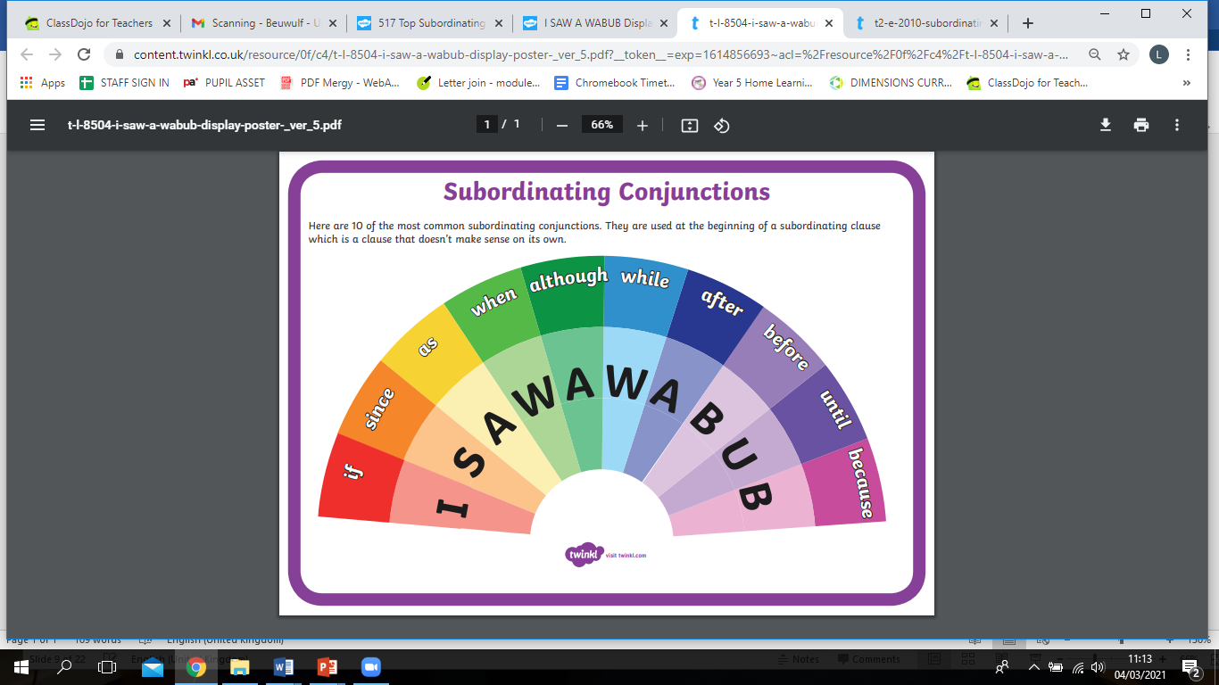

She may not have had he monster strength of her son
Worse evidence was to come, for they saw left there on the edge of the cliff the most grievous sight.
He could not bite the monster’s hoary hide, but simply bounced off.
With a scream of triumph she struck, but the mail-shirt shielded him from the sharp-edge blade.



