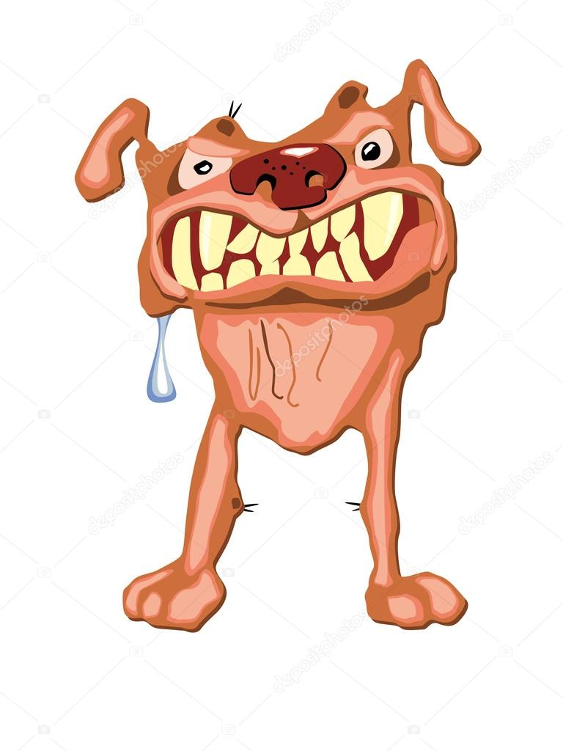
The story of Theseus and the Minotaur - Twinkl
Vicious vocabulary
- Find and copy one word which means the same as nervously.
- Find and copy one word that shows that the maze was hard to escape.
- Give the meaning of the word “dim” in this sentence:
He searched through the narrow, dim passages…
- Theseus emerged victorious…
Which of the following is closest in meaning to “emerged”?
- Was
- Came out
- Disappeared
- Left
- Theseus hoisted the black sails of his ship and headed for home.
What does the word “hoisted” suggest about the sails?

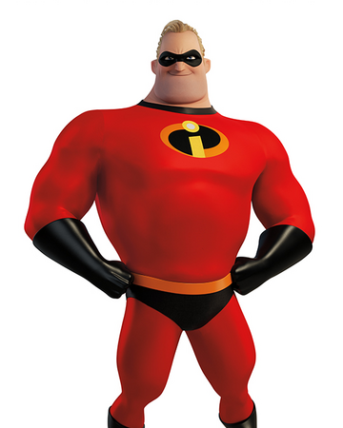
The story of Theseus and the Minotaur - Twinkl
Incredible inference
- Hands shaking, Theseus walked towards the door and went over the speech in his head.
How do you think Theseus felt as he went to speak to Aegeus? Use evidence from the text to support your answer.
- Do you think that Aegeus believed that Theseus could slay the Minotaur? Use evidence from the text to support your answer.
- Why do you think Daedalus wanted to help Theseus?
- How do you think Aegeus felt when he saw the black sails of Theseus’ ship?

The story of Theseus and the Minotaur - Twinkl

Magical meaning
- Looked up proudly at the tall, muscular warrior his son had become.
What does this description tell us about Theseus?
- …Theseus climbed into the ship alongside 13 panic-stricken children…
What does this description tell us about how the children were feeling?

- …Seeking a chance to be a hero, Daedalus agreed to help.
What does this sentence tell us about the reason Daedalus wanted to help Theseus?
- Hesitantly, he knocked.
Why did the author use the word hesitantly?

The story of Theseus and the Minotaur - Twinkl
Vicious vocabulary
- Find and copy one word which means “begged”.
- Find and copy one word that shows that journey to Crete was easy.
- …it had to be guarded deep within a complex maze…
Which of the following is closest in meaning to “complex”?
- Dark
- Narrow
- Complicated
- Large

Theseus and the Minotaur - Twinkl
Incredible inference
- Hands shaking, Theseus walked towards the door and went over the speech in his head.
How do you think Theseus felt as he went to speak to Aegeus? Use evidence from the text to support your answer.
- Aegeus called him inside and looked up proudly at the tall, muscular warrior his song had become.
Why did Aegeus look at Theseus proudly?
- Why did Aegeus plead with Theseus to find another way to defeat the Minotaur?

Theseus and the Minotaur – Twinkl
Magical meaning
- Before Aegeus could greet him, Theseus began his speech.
What does this description tell us about how long it took Theseus to begin his speech?
- …Theseus climbed into the ship alongside 13 panic-stricken children…
What does this description tell us about how the children were feeling?

