Reading Masters – Non Fiction – Balanced argument text

Word Detectives: Non Fiction – Balanced argument text
- Complete the true or false table:
Statement | True | False
Some people believe video games can keep children safe.
The certificate tells you whether the game is good or bad.
A lot of people are included in the creation of video games.
Video games are mostly aimed at children.
- What are video games?
- What was the 1st type of video game?
- When was the earliest example of a video game?
- Which games allow children to develop their creative side?
- Name two elements of creating a game.
- What are the arguments for and against?


Vital Vocabulary: Non Fiction – Balanced argument text
- Find and copy the word that tells the readers that devices can be easily moved around.
- How do parents know the game is suitable for their child?
- Find and copy one example of a causal conjunction and one example of a contrasting conjunction.
- Why can video games be harmful to children?
- How have games advanced?
- Which word has the author used to show that video games are dominating and controlling?
- Who could children disclose their information to?

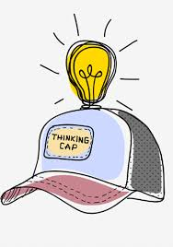
Thinking Caps: Non Fiction – Balanced argument text
- Why do you think the author has included their own recommendations in the text? 2 marks
- Why are the words ‘potential predator’ effective in convincing someone that video games are not appropriate for children?
- Which side of the argument do you agree with? Explain your answer.

