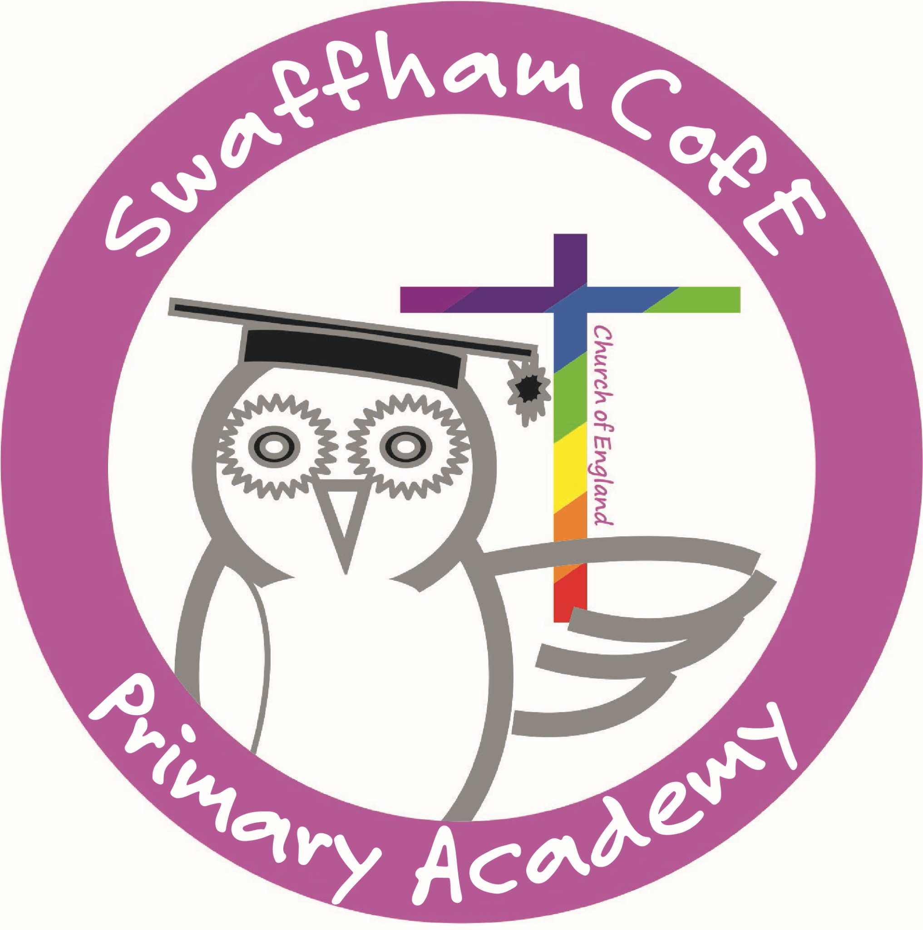
Theme | Reception | Year 1 | Year 2 | Year 3 | Year 4 | Year 5 | Year 6
Conservation | What On Earth?  Understand where Spain is in the world, how some people speak a different or more than one language, make links to what we know (include families with other cultures and backgrounds) Spanish culture - food, dress and the flag  Spanish greetings in register | Light Up The World  Develop greetings to be able to greet adults in the room and around the school  Develop the number of classroom commands you can understand and follow.  Develop understanding and use of numbers to 10 or more  Introduce primary colours in Spanish, being able to identify the colour they hear | Going Wild  Develop greetings to include our name and age.  Develop an understanding of days of the week to include months of the year.  Develop on the number of classroom commands followed with increasing difficulty  Revise learning of numbers to 10 and develop to 20. | Picture Our Planet  Revise greeting to include our name, age and develop to include feelings.  Revise numbers to 20 and learn numbers to 50  Develop on number of classroom commands followed with increasing difficulty  Learn the phonic vowel sounds + b, d, f, g, h | Under The Canopy  Revise greetings to include name, age, feelings and where we live.  Revise numbers to 50 and develop to 100 and beyond.  Revise classroom commands with increasing speed and fluency  Revise vowel sounds and previous taught phonemes + j, l, ll, m , n, ñ , p, r | Global Warning  Revise greetings to include name, age, feelings and where we live.  Revise vowel sounds and previous taught phonemes + k, ch,c, rr, s, t, v, w  Revise numbers to 100+ and introduce telling of the time to o’clock.  Revise classroom commands with increasing speed and fluency | Full of Beans  Revise greetings to include name, age, feelings and where we live.  Revise numbers to 100+ and telling of the time to o’clock.  Revise vowel sounds and previous taught phonemes + y, z, qu, x,  Learn the alphabet names in Spanish and repeat verbally.
Culture | Come Fly With Me: Asia  Introduce myself by saying my name  Follow simple verbal classroom commands in Spanish  Names of domesticated animals link with what we know (the pets we have or would like to have).  Introduce Magic words: Thank you, please, I’m sorry, may I? | Come Fly With Me: Arctic Circle  Develop on identifying primary colours to learning 5 more colours and orally verbalising the names of the colours.  Introduce days of the week through song and games.  Introduce 2-D shapes and be able to identify the shape they hear through songs and games.  Revise Magic words: Thank you, please, I’m sorry, may I? | Zero To Hero  Introduce 5 or more different feelings for children to portray and verbally repeat and supported to write (“I am feeling”…)  Revise colours and size of objects, children learn to verbally repeat and supported to write “ I can see a (large/small) (colour) (object).”  Revise fruits and develop to include drinks and snacks. Children verbally recall by tasting them and completing a written review. | Come Fly With Me: Africa  Introduce items you hold in your pencil case, learning to speak and write a simple sentence using “I have” and a colour or adjective.  Introduce Spanish foods and picnic foods. Completing a written review.  Revise days and months and develop to include today and yesterday. Learning to speak and write “today I will….” “yesterday I went….” | A Cry For Freedom  Using adjectives and colours and body parts, learn to describe a monster. Label and describe a monster’s physical appearance  Name and identify the different types of weather using the conjunction and (y). | Come Fly With Me: America  Learn time conjunctions in Spanish.-later on (mas tarde) after that (después) next (siguiente)  Revise learning to say and write personal pronouns with the verb ‘have’. e.g. we have, I have  Learn the subject names in Spanish and explain the routine of the day or week. | I Have A Dream  Create a write profile called ‘all about me’, using prior learning and known vocabulary. Include age, where you live, what you like to do what you dislike to do, favourite colour etc.
Conflict | Help Is At Hand  Name the body parts, develop an understanding through a familiar nursery rhyme (head shoulder knees and toes)  Name things around the classroom. Children follow instructions to move towards the accurate classroom object. | Unity In The Community  Develop on identifying 2-d shapes to orally verbalising the name of the shapes  Introduce the names of 5 fruits, children verbally recall fruits whilst tasting them. Learn to say my favourite is…  Class objects by their size of large and small, children compare and order objects whether they are large or small. | Land Ahoy  Revise names of animals and learn the names of places they might live. Matching the animal to the place.  Develop on identifying 2-d shapes to include 3-d shapes.  Introducing action verbs and various pronouns, children to write the sentence (I/she/he/ they/ you/ we can…) | Law And Order  Develop an understanding of yesterday and today and begin to apply learning to tomorrow. “Tomorrow I will…”  Introduce plurals and articles (a/the). Children learn the difference between definite and indefinite articles and how to use them correctly. | Athens Vs. Sparta  Revise 2-d shapes and introduce 5 or more 3-d shapes.  Learn space prepositions and build to writing simple sentences that describe where a shape or object is. | You’re Not Invited  Name the places in town and learn to write and verbalise where you have been and where you would like to go.  Name and learn the different hobbies you like and dislike and develop to explain why using the conjunctive because (porque) | Wars Of The World  Learn the names of different healthy breakfast and lunches. Children create a menu for a Spanish Cafe. Include 3 dishes and a description of each dish using adjectives.
Communication | Happy To Be Me  Listen and sing along to songs to Spanish counting up to 10. Count in Spanish to 5 or more independently.  Name our family members and draw and label in Spanish with visual vocab.  Listen to a familiar story in Spanish | Happily Ever After  Revise and develop learning of domesticated animals to animals found at the zoo.  Introduce 5 or more types of clothing, children to design and label a fairy tale character's outfit.  Listen to a familiar story in Spanish | Inter-nation Media Station  Introduce opinion phrases (I like/ I don’t like) + colours, verbs and animals  Introduce seasons and build simple sentences using (I can or I like/don’t like). | Lightning Speed  Develop an understanding of body parts by writing how many of each you have.  Develop on opinion phrases (I hate/ I love) + colours, foods, verbs and animals). | That’s All Folks  Revise family members and pets in our household.  Learn to describe ourselves, who we live with and others in our family using conjunctions such as: and, but, because (y, pero, porque) | Mission control  Learn names of the planets and describe them using adjectives. Order the planets from closest to furthest away using Spanish numbers. | A World of Bright Ideas  Plan a holiday to Spain. Learn the names of the Spanish places e.g. beaches or cities. Children to write multiple sentences on if they were to go to Spain where they would go and what they would do.

